Mexico holds top US trade spot, as Trump raised doubts on renewing USMCA

Noi Mahoney, Friday, June 12, 2026
Original Article: https://www.freightwaves.com/news/mexico-holds-top-us-trade-spot-as-trump-raised-doubts-on-renewing-usmca
Articles Reproduced by Permission of FreightWaves

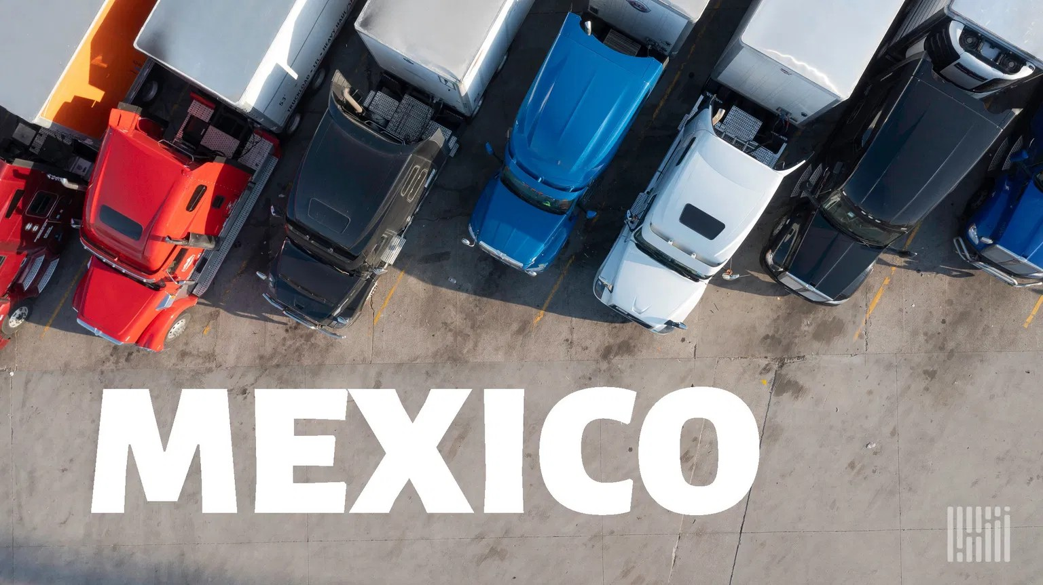
President Donald Trump says the U.S. may not renew the United States-Mexico-Canada-Agreement trade agreement even as Mexico and Canada continue to account for hundreds of billions in monthly commerce. (Photo: Jim Allen/FreightWaves)

Cross-border commerce with Mexico reached a record $86 billion in April, while China slips to No. 4

Mexico remained the largest U.S. trading partner in April, extending a streak that began in 2023 and highlighting the continued strength of North American supply chains.

The surge in cross-border trade continues despite growing uncertainty surrounding the future of the United States-Mexico-Canada Agreement (USMCA) trade pact, according to President Donald Trump.

On Wednesday, Trump said the U.S. may not renew the agreement, arguing that the U.S. does not need imports from its North American neighbors and should receive more favorable trade terms.

“I’m not looking to renew ⁠it,” Trump said according to Reuters. “We don’t need anything that Canada ​has. We don’t need anything that Mexico has, but they need everything that ​we have. They have to treat us better.”

Under the agreement, the three countries must approve a renewal by July 1 or signal their intention to withdraw, a process that could trigger a lengthy renegotiation period.

Despite Trump’s comments, USMCA negotiations are ongoing. The Office of the U.S. Trade Representative has scheduled a second round of talks with Mexico in Washington on Wednesday and Thursday focused on agriculture and competitive trade practices. It will be followed by additional discussions in Mexico City during the week of July 20.

Mexico extends lead over Canada in U.S. trade rankings
Two-way trade between the U.S. and Mexico totaled $86.04 billion in April, up 23.4% from the same month a year earlier, according to U.S. Census Bureau data analyzed by WorldCity. U.S. exports to Mexico totaled $35.34 billion, while imports reached $50.69 billion.

Mexico accounted for 16.6% of all U.S. trade in April and ranked first among U.S. trading partners in overall commerce, exports and imports. The April total was the highest monthly trade value with Mexico since WorldCity began tracking the data in 2013.

Canada ranked second among U.S. trading partners with $64.8 billion in two-way trade during April, while Taiwan surged to third place at $29.6 billion.

China slipped to fourth place at $29.2 billion in trade with the U.S., marking one of its lowest rankings among U.S. trading partners in decades as tariffs and supply-chain diversification continue to reshape global commerce.

Overall U.S. trade totaled $518.45 billion in April, with exports of $218 billion and imports of $300.46 billion. Total trade increased 11.6% compared to April 2025.

Border gateways drive growth
Cross-border land ports continued to dominate U.S.-Mexico commerce.

Port Laredo remained the busiest U.S.-Mexico gateway in April, handling $33.35 billion in trade, a 21% increase from a year earlier.

The crossing accounted for nearly 39% of all U.S.-Mexico trade by value. Other leading gateways included the Ysleta-Zaragoza International Bridge in El Paso ($12.27 billion), Otay Mesa in California ($4.99 billion), Santa Teresa, New Mexico ($4.88 billion), and Eagle Pass, Texas ($4.05 billion).

The strength of border trade was also reflected in national rankings. Port Laredo was the busiest U.S. trade gateway overall in April, handling $34.16 billion in commerce with all trading partners, ahead of Chicago O’Hare International Airport ($33.9 billion) and the John F. Kennedy International Airport ($29.1 billion).

